Rahul thaker

**ANZ – Data insights**

Index:

Basic insights, Average day, Average week, Challenge.

**Know the data**

The data contains records of each transactions with 23 columns and 12043 records.

**Basic insights:**

1]The **average transaction amount** for each month are as follows:

August:3943

September:4013

October:4087

Average transaction per month:4014

2] The **average transaction per day** in 3 months is 190

3] The **average age** is 30

The **average balance** is 14704

**Average/ideal statistics over an interval:**

The records have date and extraction columns which contain day, month, year and time for each of the transaction/record

Extracting and segmenting this data based on time/date. We can get some **useful and general** insights:

**An average day:**

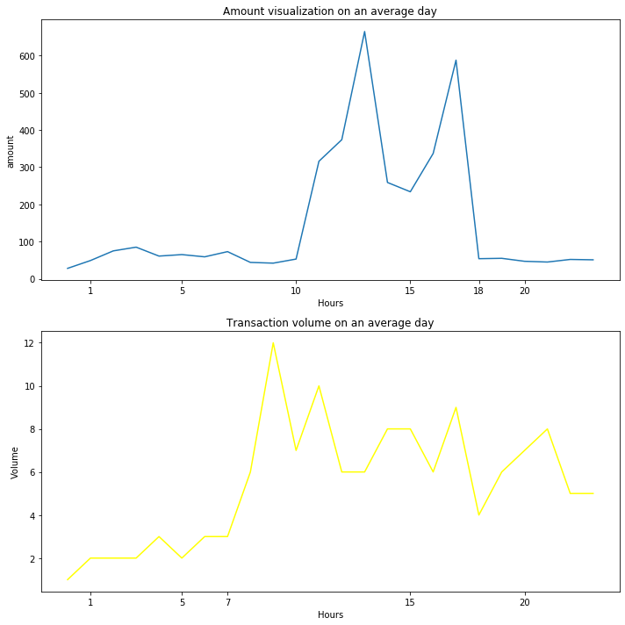

We can see the amount of **transactions are high from 10th to 18th hour**

And the volume of transactions has a **steep increase from the 7th hour**.

(calculated by taking the average values of the whole database)

**An average week:**

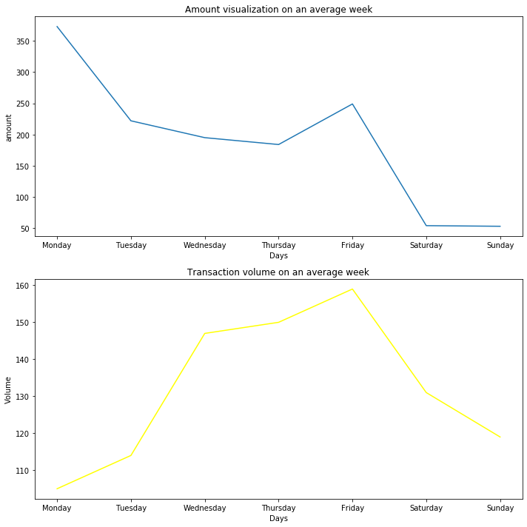

**One odd thing** could be noticed that

Even though the **amount of transactions on Monday is high** the **volume of transactions is low (not by a lot).** A similar case is occurring for Tuesday

Could be because of outliers discussed further.

On **Saturdays and Sundays, the amount of transactions is very low**

**The peak amount of Number of transactions and the volume occurs on Friday**

**Outliers:**

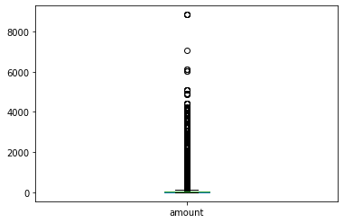

The box plot shows the outliers which are evident. And obviously could cause a **predilection towards higher values** on certain days.

Which could be responsible for the above paradox of **Monday and Tuesday having more transaction amount and less volume of transaction**

**CHALLENGE/LOCATION:**

The whole dataset is based in Australia. The latitudes and longitudes and the name of the person are given.

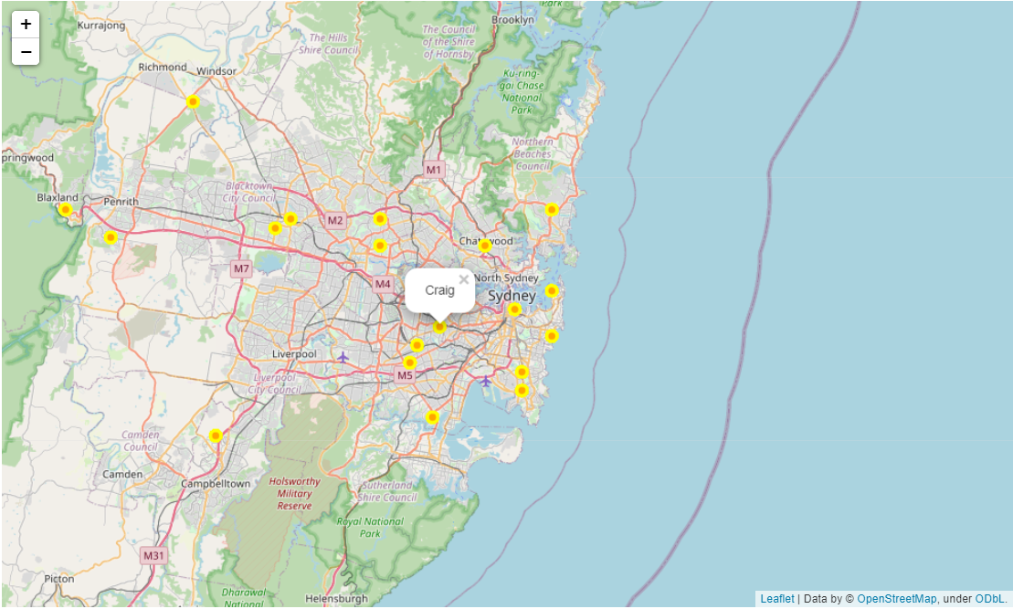

The visual shows the **density** of transactions is more near M5. And since it's an interactive map the popup label shows the **name** for each marker